**Ideation Phase**

**Brainstorm & Idea Prioritization Template**

|  |  |
| --- | --- |
| Date | 30 September 2022 |
| Team ID | PNT2022TMID51059 |
| Project Name | Gas leakage monitoring and alarming system |
| Maximum Marks | 4 Marks |

**Brainstorm & Idea Prioritization Template:**

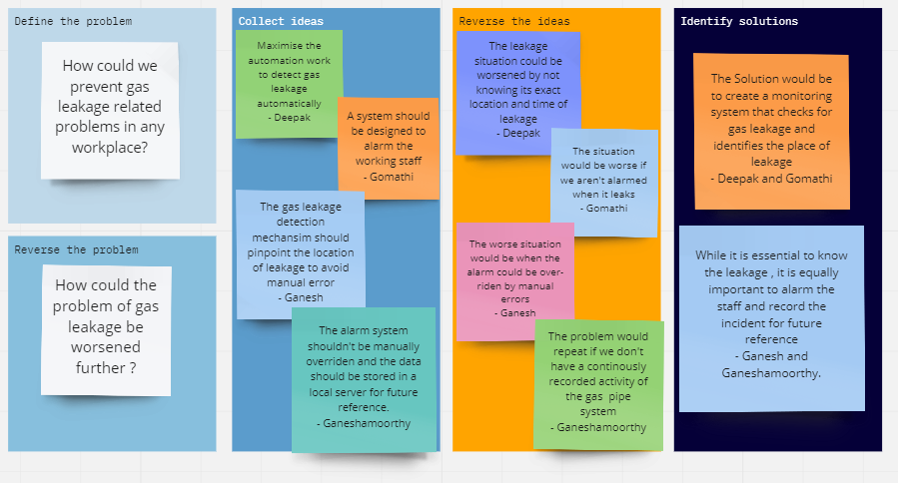Brainstorming provides a free and open environment that encourages everyone within a team to participate in the creative thinking process that leads to problem solving. Prioritizing volume over value, out-of-the-box ideas are welcome and built upon, and all participants are encouraged to collaborate, helping each other develop a rich amount of creative solutions.

A brainstorming session by the team produced these solutions and greater clarity was induced.